HFC/ACD 004 2020
IN THE HIGH COURT OF SIERRA LEONE HOLDEN AT FREETOWN
(ANTI-CORRUPTION DIVISION)

THE STATE
vs
ABDUL RAZAK KABBA

BEFORE THE HON. JUSTICE MR. JUSTICE A.S ALLIEU-J DATED THE 2 3RD DAY OF APRIL, 2020

HAVING HEARD N. B. E Davies Esq. Counsel for the State who offered no evidence against the accused Abdul Razak Kabba on Counts 3-16 stated above in this case;
I HEREBY discharged the accused on Counts 3, 4, 5, 6, 7, 8, 9, 10, 11, 12,
13, 14 15 and 16 respectively.
HAVING also heard the plea of Guilty of the accused on Counts One (1) and
Two (2),
I HEREBY Convict the accused on the said counts i.e. Counts 1 and 2.
HAVING HEARD the plea in mitigation of D.J Lavalie Esq. on behalf of the accused person after the accused had pleaded guilty on Counts 1 and 2 of the indictment before the court, the accused Abdul Razak Kabba is sentenced as follows:-
Count I-Accused is sentenced to a fine of Le 50,000,000.00 (Fifty Million Leones) or a term of 5 years imprisonment.
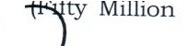
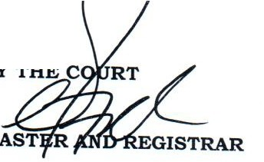
Count 2-Accused is sentenced to a fine of Le 50,000 ,00 0.0 ,._..., , Leones) or a term of 5 years imprisonment.
Both sentences to run consecutively.

