I n The High Court of Sierra Leone

T h e State vs. Abdul Barrie

Sarrifou Harlston / or the State
I S Yillah with him A Sillah and A Sherriff for the Accused

Reginald Sydney Fynn JA, Presiding
Sentencing Judgment

The Accused Abdul Barrie has pleaded guilty to count 5 on the indictment. In that count he is charged with having failed to disclose to a public body, in writing an interest he has in a company, contrary to Section 45(3) of the Anti-Corruption Act 2008. Whilst this Offence may appear quite innocuous it is truly one of the principal gate keepers for integrity in Public life . It ensures that a person in a position of t rust who acts for and on behalf of government must disclose any interest in a company with whom he transacts business as a government official. Of course whilst having business dealings on behalf of government with a company he has an interest in, a government official is now conflicted and his integrity is put to great strain. He can in these circumstances if he is not of stout and trusty character be led to unjustly enrich himself through such a company, agreeing on behalf of government to pay his own company unfair and overvalued amounts. If however he were to disclose his interest other officials around him will now be more vigilant and assist in protecting government's interests and funds. It is such a danger that Section 45 of the act seeks to protect against.
I am fully aware that the accused was at the material time a Deputy Minister of the Government of Sierra Leone. This is an office of significant importance and immense trust, no doubt . The betrayal of such t rust and so blatantly should normally be met with stout and clear punishment. However the law makes provisions for rewarding a guilty plea. Similarly so the candor and or remorse that fuels such a plea together with the savings on court time which are
, I
attendant must accrue something in the accused persons favour. In the present circumstances it is only these that will stay my hand on custodial sentence without an alternative. I reiterate
the gravity of the offence despite its subtle facade. Having taken into consideration defence
I
counsel's plea in mitigation I hereby order as follows ;

The accused is sentenced to a term of three years imprisonment or a fine of Le 250M
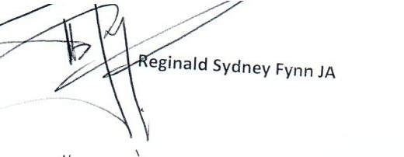
{which amount should be paid within one month of today's date.

Dated 24th April 2019

V

